Assignment 6

**Question 1:** Write a program to demonstrate the functionality of the various access specifiers.

Public : accessible from anywhere

Protected : accessible in the same class, classes in the same package as well as subclasses in other packages

Default : accessible in the same class and classes in the same package

Private : accessible in the same class only

To demonstrate the above features create a class test inside package pkg with four data members of different access specifiers. Create another class test1 inside the same package pkg and access the data members, comment out the ones which are not visible. Lastly create another class test2 in another package pkg1 as a subclass of test and access the permissible data members.

**Code for class test:**

package pkg;

public class test

{

public int pub_int;

protected int pro_int;

int def_int;

private int pri_int;

public test()

{

pub_int = 0;

pro_int = 1;

def_int = 2;

pri_int = 3;

}

}

**Code for class test1:**

package pkg;

public class test1

{

public static void main(String[] args)

{

test obj = new test();

System.out.print(obj.pub_int);

System.out.print(obj.pro_int);

System.out.print(obj.def_int);

//System.out.print(obj.pri_int);

}

}

**Code for class test2:**

package pkg1;

import pkg.*;

public class test2 extends test

{

test2()

{

System.out.print(pub_int);

System.out.print(pro_int);

//System.out.print(def_int);

//System.out.print(pri_int);

}

public static void main(String[] args)

{

test2 obj = new test2();

}

}

**Output:**

When the lines were **not commented**:

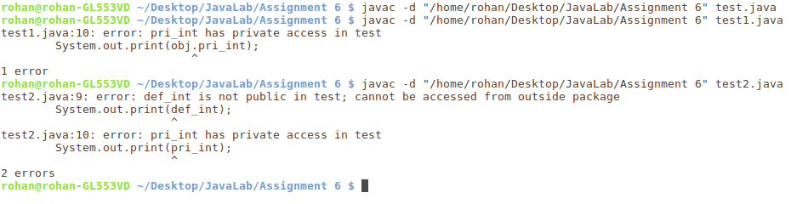

When the lines were **commented** as shown in the code:

